**Visvesvaraya Technological University**

### Belgavi-590014



**Web Technology Laboratory**

**A Mini-Project Report**

**On**

***“Online Food Ordering System”***

*Submitted in partial fulfillment of the requirements for the 7th semester of* ***Bachelor of Engineering in Computer Science and Engineering*** *of Visvesvaraya Technological University, Belagavi*

Submitted by:

**SHASHANK ASHOK GADAVI 1RN17CS086**

**SHASHANK S 1RN17CS089**

Under the Guidance of:

**Mrs. Manjula L**

**Asst Professor**

**Dept. of CSE**



**Department of Computer Science and Engineering**

**RNS Institute of Technology**

**Channasandra, Dr. Vishnuvardhan Road, RR Nagar Post, Bengaluru – 560 098**

**2020-2021**

**RNS Institute of Technology**

Channasandra, Uttarahalli - Kengeri Main Road,

Bengaluru - 560 098

**Department of Computer Science & Engineering**



**CERTIFICATE**

Certified that the mini project work entitled **“Online Food Ordering System”** has been successfully carried out by **Shashank Ashok Gadavi** bearing USN **1RN17CS086** and **Shashank S** bearing USN **1RN17CS089**, bonafide students of **RNS** **Institute of Technology** in partial fulfillment of the requirements for the **7th semester** of **Bachelor of Engineering** in **Computer Science and Engineering** of **Visvesvaraya Technological University**, Belagavi, during the academic year 2020-2021. It is certified that all corrections/suggestions indicated for Internal Assessment have been incorporated in the report deposited in the departmental library. The project report has been approved as it satisfies the Web Technology laboratory requirements of 7th semester BE, CSE.

**Mrs. Manjula L Dr. Kiran P**

**Asst Professor Head of Department**

**Dept. of CSE Dept. of CSE**

**External Viva:**

**Name of the Examiners Signature with Date:**

**1.**

**2.**

**ACKNOWLEDGMENT**

Any achievement, be it scholastic or otherwise does not depend solely on the individual efforts but on the guidance, encouragement and cooperation of intellectuals, elders and friends. A number of personalities, in their own capacities have helped us in carrying out this project work.

We would like to take this opportunity to thank them all. We are grateful to **Dr. M K Venkatesha,** Principal, RNSIT, Bangalore, for his support towards completing our project.

We would like to thank **Dr. Kiran P**, Prof & Head, Department of Computer Science & Engineering, RNSIT, Bangalore, for his valuable suggestions and expert advice.

We deeply express our sincere gratitude to our guides **Mrs. Manjula L, Asst Prof, Department of CSE, RNSIT, Bangalore** and **Mr. Shrinivas Biradar**, **Asst Prof, Department of CSE, RNSIT, Bangalore,** for their able guidance, regular source of encouragement and assistance throughout this project.

We would like to thank all the teaching and non-teaching staff of Department of Computer Science & Engineering RNSIT, Bangalore for their constant support and encouragement.

Date: **Shashank Ashok Gadavi 1RN17CS086**

Place: Bengaluru **Shashank S 1RN17CS089**

**ABSTRACT**

The objective and scope of this project is to record the details of all the food items, customer and managers of respective restaurant. Basically, this project helps in reducing the paper documentation. The purpose of “Online Food Ordering System” is to automate the existing manual system by the help of computerized equipment's and full-fledged computer software, fulfilling their requirements, so that their valuable data/information can be stored for a longer period with easy accessing and manipulation of the same. The required software is easily available and easy to work with.

Online Food Ordering System can lead to error free, secure, reliable and fast management system. Thus, it will help organization in better utilization of resources and also it can maintain computerized records without redundant entries. The system is very user friendly and it is anticipated that functions of the system will be easily accessed by administrator, customer and manager with their respective username and password. This application contains detailed information of all the food items and restaurants names. It also allows access for the administrator of Restaurant to add new food items& restaurants into the database.

The mini project has been implemented using PHP and HTML as front end and MySQL as back end.

|  |  |  |  |
| --- | --- | --- | --- |
|  |  | **Table of Contents** |  |
| **CERTIFICATE** | | |  |
| **ABSTRACT ..........................................................................................................................** | | | **i** |
| **ACKNOWLEDGMENT ....................................................................................................** | | | **ii** |
| **Table of Contents ...............................................................................................................** | | | **iii** |
| **List of Figures ....................................................................................................................** | | | **iv** |
| **List of Tables ......................................................................................................................** | | | **iv** |
| **1** | **INTRODUCTION .....................................................................................................** | | **1** |
|  | 1.1 | Introduction to web ............................................................................................. | 1 |
|  | 1.2 | HTML ................................................................................................................. | 1 |
|  | 1.3 | PHP ..................................................................................................................... | 2 |
|  | 1.4 | Javascript ............................................................................................................ | 2 |
|  | 1.5 | XML.................................................................................................................... | 3 |
|  | 1.6 | MySQL………………………………………………………………………. | 3 |
| **2** | **SYSTEM ANALYSIS ...............................................................................................** | | **5** |
|  | 2.1 | Introduction (analysis of ur project problem statement)……............................. | 5 |
|  | 2.2 | Resource requirement ......................................................................................... | 5 |
| **3** | **SYSTEM DESIGN (Based on ur project)....................................................** | | **7** |
|  | 3.1 | System Perspective ............................................................................................. | 7 |
|  | 3.2 | Architecture Diagram ......................................................................................... | 7 |
|  | 3.3 | Use Case Diagram .............................................................................................. | 8 |
|  | 3.4 | Activity Diagram ................................................................................................ | 9 |
|  | 3.5 | Sequence Diagram ............................................................................................ | 10 |
| **4** | **IMPLEMENTATION (Based on ur project)……..................................................** | | **12** |
|  | 4.1 | Discussion of code segment .............................................................................. | 12 |
|  | 4.2 | Database connection ......................................................................................... | 12 |
|  | 4.3 | Admin login ...................................................................................................... | 13 |
|  | 4.4 | Registration form .............................................................................................. | 13 |
|  | 4.5 | Visitor login ...................................................................................................... | 14 |
|  | 4.6 | Table description(if required)........................................................... ………. | 15 |
| **5** | **SOFTWARE TESTING** | | 18 |
| **6** **DISCUSSION OF THE RESULTS .......................................................................** | | | **19** |
|  | 6.1 | Screen Shots ...................................................................................................... | 19 |
| **7** **CONCLUSION AND FUTURE ENHANCEMENT............................................** | | | **23** |
|  | **REFERENCES........................................................................................................** | | **24** |

**CHAPTER 1**

**INTRODUCTION**

**1.1 DATABASE TECHNOLOGIES**

The essential feature of database technology is that it provides an internal representation (model) of the external world of interest. Examples are the representation of a particular date/time/flight/aircraft in airline reservation or of item code/item description/quantity on has  
the technology involved is concerned primarily with maintaining the internal representation consistent with external reality; this involves the results of extensive R&D over the past 30 years in areas such as user requirements analysis, data modeling, process modeling, data integrity, concurrency, transactions, file organization, indexing, rollback and recovery, persistent programming, object-orientation, logic programming, deductive database systems, active database systems... and in all these (and other) areas there remains much to be done.

The essential point is that database technology is a CORE TECHNOLOGY with links to:

* Information management / processing
* Data analysis / statistics
* Data visualization / presentation
* Multimedia and hypermedia
* Office and document systems
* Business processes, workflow, CSCW (computer-supported cooperative work)

Relational DBMS is the modern base technology for many business applications. It offers flexibility and easy-to-use tools at the expense of ultimate performance. More recently relational systems have started to extend their facilities in the directions of information retrieval, object-orientation and deductive/active systems leading to the so-called 'Extended Relational Systems'.

Information Retrieval Systems started with handling library catalogues and extended to full free-text utilizing inverted index technology with a lexicon or thesaurus. Modern systems utilize some KBS (knowledge-based systems) techniques to improve retrieval.

Object-Oriented DBMS started for engineering applications where objects are complex, have versions and need to be treated as a complete entity. OODBMSs share many of the OOPL features such as identity, inheritance, late binding, overloading and overriding. OODBMSs have found favour in engineering and office systems but have not yet been successful in traditional application areas.

Deductive / Active DBMS have emerged over the last 20 years and combine logic programming technology with database technology. This allows the database itself to react to external events and to maintain dynamically its integrity with respect to the real world.

**1.2 CHARACTERISTICS OF DATABASE APPROACH**

Traditionally, data was organized in file formats. DBMS was a new concept then, and all the research was done to make it overcome the deficiencies in traditional style of data management. A modern DBMS has the following characteristics −

* Real-world entity − A modern DBMS is more realistic and uses real-world entities to design its architecture. It uses the behavior and attributes too. For example, a school database may use students as an entity and their age as an attribute.
* Relation-based tables − DBMS allows entities and relations among them to form tables. A user can understand the architecture of a database just by looking at the table names.
* Isolation of data and application − A database system is entirely different than its data. A database is an active entity, whereas data is said to be passive, on which the database works and organizes. DBMS also stores metadata, which is data about data, to ease its own process.
* Less redundancy − DBMS follows the rules of normalization, which splits a relation when any of its attributes is having redundancy in values. Normalization is a mathematically rich and scientific process that reduces data redundancy.
* Consistency − Consistency is a state where every relation in a database remains consistent. There exist methods and techniques, which can detect attempt of leaving database in inconsistent state. A DBMS can provide greater consistency as compared to earlier forms of data storing applications like file-processing systems.
* Query Language − DBMS is equipped with query language, which makes it more efficient to retrieve and manipulate data. A user can apply as many and as different filtering options as required to retrieve a set of data. Traditionally it was not possible where file-processing system was used.
* ACID Properties − DBMS follows the concepts of Atomicity, Consistency, Isolation, and Durability (normally shortened as ACID). These concepts are applied on transactions, which manipulate data in a database. ACID properties help the database stay healthy in multi-transactional environments and in case of failure.
* Multiuser and Concurrent Access − DBMS supports multi-user environment and allows them to access and manipulate data in parallel. Though there are restrictions on transactions when users attempt to handle the same data item, but users are always unaware of them.
* Multiple views − DBMS offers multiple views for different users. A user who is in the Sales department will have a different view of database than a person working in the Production department. This feature enables the users to have a concentrate view of the database according to their requirements.
* Security − Features like multiple views offer security to some extent where users are unable to access data of other users and departments. DBMS offers methods to impose constraints while entering data into the database and retrieving the same at a later stage. DBMS offers many different levels of security features, which enables multiple users to have different views with different features. For example, a user in the Sales department cannot see the data that belongs to the Purchase department. Additionally, it can also be managed how much data of the Sales department should be displayed to the user. Since a DBMS is not saved on the disk as traditional file systems, it is very hard for miscreants to break the code.

**1.3 APPLICATIONS OF DBMS**

Applications where we use Database Management Systems are:

* **Telecom**: There is a database to keeps track of the information regarding calls made, network usage, customer details etc. Without the database systems it is hard to maintain that huge amount of data that keeps updating every millisecond.
* **Industry**: Where it is a manufacturing unit, warehouse or distribution centre, each one needs a database to keep the records of ins and outs. For example distribution centre should keep a track of the product units that supplied into the centre as well as the products that got delivered out from the distribution centre on each day; this is where DBMS comes into picture.
* **Banking System**: For storing customer info, tracking day to day credit and debit transactions, generating bank statements etc. All this work has been done with the help of Database management systems.
* **Education sector**: Database systems are frequently used in schools and colleges to store and retrieve the data regarding student details, staff details, course details, exam details, payroll data, attendance details, fees details etc. There is a hell lot amount of inter-related data that needs to be stored and retrieved in an efficient manner.
* **Online shopping**: You must be aware of the online shopping websites such as Amazon, Flip kart etc. These sites store the product information, your addresses and preferences, credit details and provide you the relevant list of products based on your query. All this involves a Database management system.
  1. **PROBLEM DESCRIPTION/STATEMENT**

The main objective of our project on Online Food Ordering System is to manage the details of Food Item, Category, Customer, Order, Confirm Order. The project is totally built at administrative end and thus only the administrator is guaranteed the access. The purpose of the project is to build an application program to reduce the manual work for managing the Food Item and Payment. It tracks all the details about the Customer, Order, Confirm Order.

**CHAPTER 2**

**REQUIREMENT ANALYSIS**

**2.1 HARDWARE REQUIREMENTS**

The Hardware requirements are very minimal and the program can be run on most of the machines.

|  |  |  |
| --- | --- | --- |
| Processor | : | Pentium4 processor |
| Processor Speed | : | 2.4 GHz |
| RAM | : | 1 GB |
| Storage Space | : | 40 GB |
| Monitor Resolution | : | 1024*768 or 1336*768 or 1280*1024 |

**2.2 SOFTWARE REQUIREMENTS**

1. Operating System used: Windows 10
2. Brackets Text Editor: HTML, CSS, Bootstrap, PHP
3. WAMP Server: Apache, MySQL, PhpMyAdmin
4. Browser that supports HTML and JavaScript

**2.3 FUNCTIONAL REQUIREMENTS**

* + 1. **Major Entities**

1 Manager

2 Customer

3 Restaurant_info

4 Menu

5 Transaction

**2.3.2 End User Requirements**

1. Reduces manual effort.

2. Building user-friendly database.

3. Maintains database efficiently.

**2.3.3.1 HTML**

Hypertext Markup Language (HTML) is the standard markup language for creating web pages and web applications. With Cascading Style Sheets (CSS) and JavaScript it forms a triad of cornerstone technologies for the World Wide Web. Web browsers receive HTML documents from a web server or from local storage and render them into multimedia web pages. HTML describes the structure of a web page semantically and originally included cues for the appearance of the document.

HTML elements are the building blocks of HTML pages. With HTML constructs, images and other objects, such as interactive forms, may be embedded into the rendered page. It provides a means to create structured documents by denoting structural semantics for text  
such as headings, paragraphs, lists, links, quotes and other items. HTML elements are delineated by tags, written using angle brackets. Tags such as <img /> and <input /> introduce content into the page directly. Others such as <p>...</p> surround and provide information about document text and may include other tags as sub-elements. Browsers do not display the HTML tags, but use them to interpret the content of the page.

HTML can embed programs written in a scripting language such as JavaScript which affect the behavior and content of web pages. Inclusion of CSS defines the look and layout of content.

**2.3.3.2 CSS**

Cascading Style Sheets (CSS) is a style sheet language used for describing the presentation of a document written in a markup language. Although most often used to set the visual style of web pages and user interfaces written in HTML and XHTML, the language can be applied to any XML document, including plain XML, SVG and XUL, and is applicable to rendering in speech, or on other media. Along with HTML and JavaScript, CSS is a cornerstone technology used by most websites to create visually engaging webpages, user interfaces for web applications, and user interfaces for many mobile applications.

CSS is designed primarily to enable the separation  
of presentation and content, including aspects such as the layout, colors, and  
fonts. This separation can improve content accessibility, provide more  
flexibility and control in the specification of presentation characteristics, enable multiple HTML pages to share formatting by specifying the relevant CSS in a separate .CSS file, and reduce complexity and repetition in the structural content.

**2.3.3.3 BOOTSTRAP**

Bootstrap is a free and open-source front-end web framework for designing websites and web applications. It contains HTML and CSS based design templates for typography, form, buttons, navigation and other interface components, as well as option JavaScript extensions. Unlike many web frameworks, it concerns itself with front-end development only. Bootstrap is modular and consists of a series of “Less Stylesheets” that implement   
various components of the toolkit. These stylesheets are generally compiled into a bundle and included in web pages, but individual components can be included or removed. Bootstrap provides a number of configuration variables that control things such as color and padding of various components.

**2.3.4 PHP**

PHP is a server-side scripting language designed primarily for web development but also used as a general-purpose programming language. Originally created by Rasmus Lerdorf in 1994, the PHP reference implementation is now produced by The PHP Development Team. PHP originally stood for Personal Home Page, but it now stands for the recursive acronym PHP: Hypertext Preprocessor.

PHP code may be embedded into HTML or HTML5 markup, or it can be used in combination with various web template systems, web content management systems and web frameworks. PHP code is usually processed by a PHP interpreter implemented as a module in the web server or as a Common Gateway Interface (CGI) executable. The web server software combines the results of the interpreted and executed PHP code, which may be any type of data, including images, with the generated web page. PHP code may also be executed with a command-line interface (CLI) and can be used to implement standalone graphical applications.

The standard PHP interpreter, powered by the Zend Engine, is free software released under the PHP License. PHP has been widely ported and can be deployed on most web servers on almost every operating system and platform, free of charge. The PHP language evolved without a written formal specification or standard until 2014, leaving the canonical PHP interpreter as a de facto standard. Since 2014 work has gone on to create a formal PHP specification. HP development began in 1995 when Rasmus Lerdorf wrote several Common Gateway Interface (CGI) programs in C, which he used to maintain his personal homepage. He extended them to work with web forms and to communicate with databases, and called this implementation "Personal Home Page/Forms Interpreter" or PHP/FI.

PHP/FI could help to build simple, dynamic web applications. To accelerate bug reporting and to improve the code, Lerdorf initially announced the release of PHP/FI as"Personal Home Page Tools (PHP Tools) version 1.0" on the Usenet discussion group on June 8, 1995 This release already had the basic functionality that PHP has as of 2013. This included Perl-like variables, form handling, and the ability to embed HTML. The syntax resembled that of Perl but was simpler, more limited and less consistent.

**2.3.5 Apache Server**

Apache HTTP Server, colloquially called Apache, is free and open-source cross-platform web server software, released under the terms of Apache License 2.0. Apache is developed and maintained by an open community of developers under the auspices of the Apache Software Foundation.

Apache supports a variety of features, many implemented as compiled modules which extend the core functionality. These can range from server-side programming language support to authentication schemes. Some common language interfaces support Perl, Python, Tcl, and PHP. Popular authentication modules include mod_access, mod_auth, mod_digest, and mod_auth_digest, the successor to mod_digest. A sample of other features include Secure Sockets Layer and Transport Layer Security support (mod_ssl), a proxy module (mod_proxy), a URL rewriting module (mod_rewrite), custom log files (mod_log_config), and filtering support (mod_include and mod_ext_filter).

Popular compression methods on Apache include the external extension module, mod_gzip, implemented to help with reduction of the size (weight) of Web pages served over HTTP. ModSecurity is an open source intrusion detection and prevention engine for Web applications. Apache logs can be analyzed through a Web browser using free scripts, such as AWStats/W3Perl or Visitors.

Virtual hosting allows one Apache installation to serve many different Web sites. For example, one machine with one Apache installation could simultaneously serve www.example.com, [www.example.org](http://www.example.org), test47.test-server.example.edu, etc.

Apache features configurable error messages, DBMS-based authentication databases, and content negotiation. It is also supported by several graphical user interfaces (GUIs).It supports password authentication and digital certificate authentication. Because the source code is freely available, anyone can adapt the server for specific needs, and there is a large public library of Apache add-ons.

**2.3.6 MySQL**

MySQL is a Relational Database Management System (RDBMS). MySQL server can manage many databases at the same time. In fact, many people might have different databases managed by a single MySQL server. Each database consists of a structure to hold the data and the data itself. A data-base can exist without data, only a structure, be totally empty, twiddling its thumbs and waiting for data to be stored in it.

Data in a database is stored in one or more tables. You must create the data-base and the tables before you can add any data to the database. First you create the empty database. Then you add empty tables to the database. Database tables are organized like other tables that you’re used in rows and columns. Each row represents an entity in the database, such as a customer, a book, or a project. Each column contains an item of information about the entity, such as a customer name, a book name, or a project start date. The place where a particular row and column intersect, the individual cell of the table, is called a field. Tables in databases can be related. Often a row in one table is related to several rows in another table. For instance, you might have a database containing data about books you own. You would have a book table and an author table. One row in the author table might contain information about the author of several books in the book table. When tables are related, you include a column in one table to hold data that matches data in the column of another table.

MySQL, the most popular Open Source SQL database management system, is developed, distributed, and supported by MySQL AB. MySQL AB is a commercial company, founded by the MySQL developers. It is a second generation Open Source company that unites Open Source values and methodology with a successful business model.

* MySQL is a database management system. A database is a structured collection of data. It may be anything from a simple shopping list to a picture gallery or the vast amounts of information in a corporate network. To add, access, and process data stored in a computer database, you need a database management system such as MySQL Server. Since computers are very good at handling large amounts of data, database management systems play a central role in computing, as standalone utilities, or as parts of other applications.
* MySQL is a relational database management system. A relational database stores data in separate tables rather than putting all the data in one big storeroom. This adds speed and flexibility. The SQL part of “MySQL” stands for “Structured Query Language.” SQL is the most common standardized language used to access databases and is defined by the ANSI/ISO SQL Standard. The SQL standard has been evolving since 1986 and several versions exist. “SQL-92” refers to the standard released in 1992, “SQL:1999” refers to the standard released in 1999, and“SQL:2003” refers to the current version of the standard. We use the phrase “the SQLstandard” to mean the current version of the SQL Standard at any time.
* MySQL software is Open Source. Open Source means that it is possible for anyone to use and modify the software. Anybody can download the MySQL software from the Internet and use it without paying anything. If you wish, you may study the source code and change it to suit your needs. The MySQL software uses the GPL (GNU General Public License), to define what you may and may not do with the software in different situations. The MySQL Database Server is very fast, reliable, and easy to use.

MySQL Server was originally developed to handle large databases much faster than existing solutions and has been successfully used in highly demanding production environments for several years. Although under constant development, MySQL Server today offers a rich and useful set of functions. Its connectivity, speed, and security make MySQL Server highly suited for accessing databases on the Internet.

* MySQL Server works in client/server or embedded systems. The MySQL Database Software is a client/server system that consists of a multi-threaded SQL server that supports different back ends, several different client programs and libraries, administrative tools, and a wide range of application programming interfaces (APIs).

**CHAPTER 3**

**DATABASE DESIGN**

**3.1 Entities, Attributes and Relationships**

1. Manager : M_id ,,M_Name,Age,M_Phno, Pass_wd
2. Player : P_Id ,P_Name ,Dob ,Age ,Country ,P_Phone ,Format ,Pass_wd
3. Player_info : P_Id ,Tot_matches ,Tot_Runs ,Tot_Wickets ,Strike_rate ,50s ,100s
4. Player_manager : M_id ,Salary_Paid ,P_id ,T_id
5. Team : Team_Id ,Name ,Established_Year

**3.2 Identify Major entities, attributes and relationship**

1. **Manager:**

Manager entity consist of his personal details.

1. **Player**:

The Player entity contains player personal details.

1. **Player_info:**

The Player_info entity gives indidual players carrier details.

1. **Player_manager:**

The Player_manager entity gives the details about the salary paid by manager

to player.

1. **Team:**

The Team entity gives in which year particular team got established.

**3.3 ER DIAGRAM**

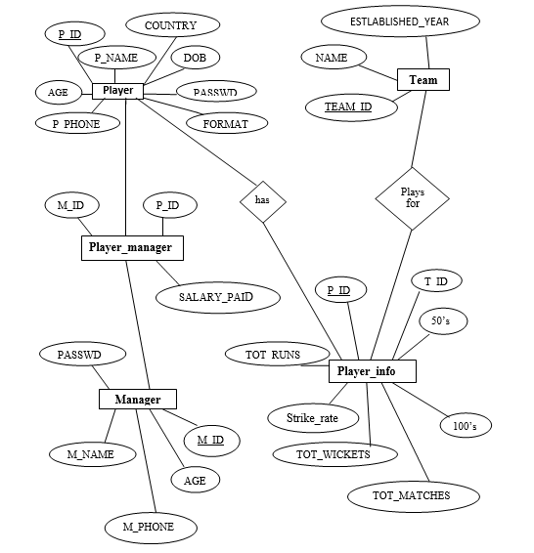

Fig 3.1: ER Diagram

**3.4 Relational Schema**

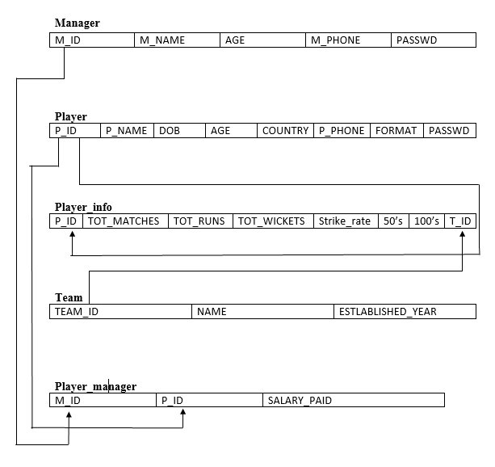

Fig 3.2: Relational Schema

**CHAPTER 4**

**IMPLEMENTATION**

**4.1 Creating Database Connection**

1 PHP provides built-in database connectivity for a wide range of databases – MySQL, PostgreSQL, Oracle, Berkeley DB, Informix, Lotus Notes, and more.

2 Use either mysql_connect or mysql_pconnect to create database connection.

3 mysql_connect: connection is closed at end of script (end of page).

4 mysql_pconnect: creates persistent connection -connection remains even after end of the page .

5 Connect to the MySQL server

5.1 $connection = mysql_connect("localhost", $username, $password);

6 Access the database

6.1 mysql_select_db("databasename", $connection);

7 Perform SQL operations

Example: $result = mysql_query ($query, $connection)

8. Disconnect from the server

8.1 mysql_close($connection);

**4.2 Pseudo Code For Major Functionalities**

**CHAPTER 5**

**RESULTS, SNAPSHOTS AND DISCUSSIONS**

This mini project starts at home page where we have displayed many slides regarding IPL infrastructure, first admin can login with valid name and password then he will have authority to add data about member who ever enters into any of the IPL team that the manager has taken, manager assigned for each team having 15 players, and he can also view the players available in his team.

Index Page

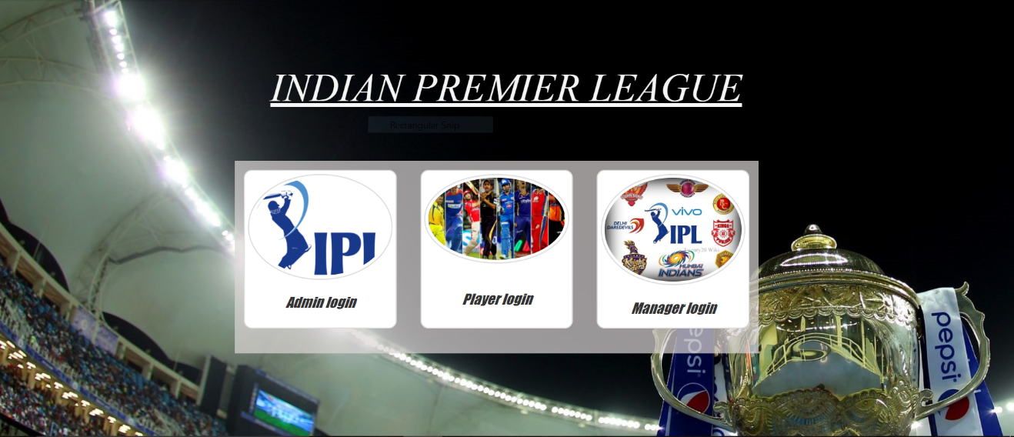

Admin login

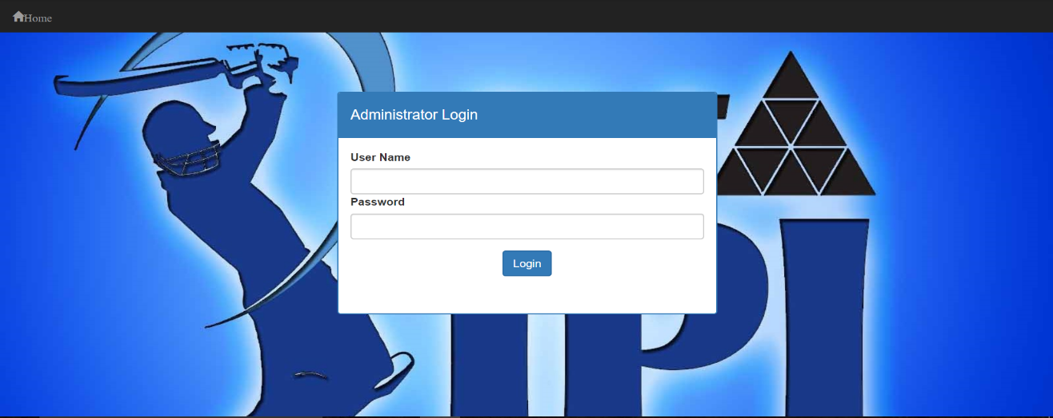

Admin

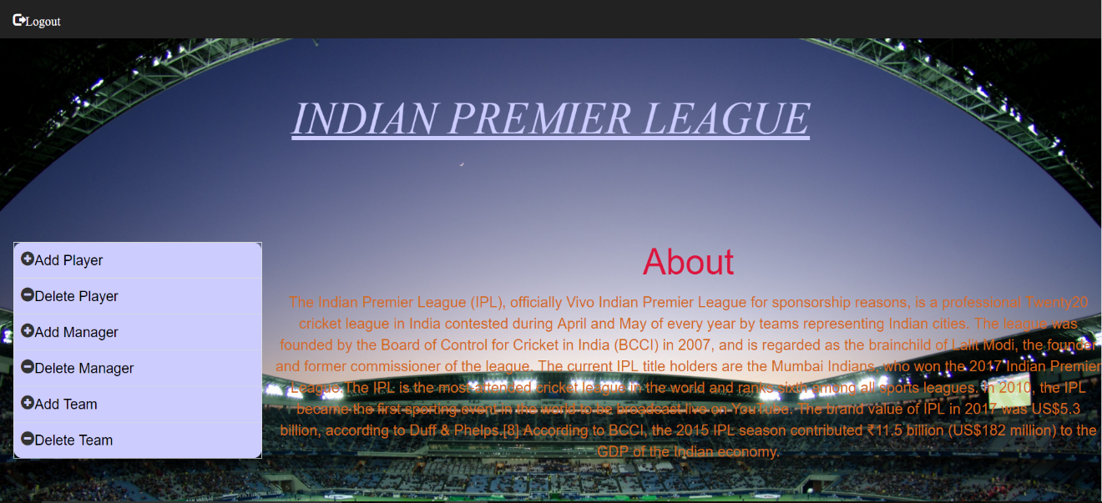

Add Player

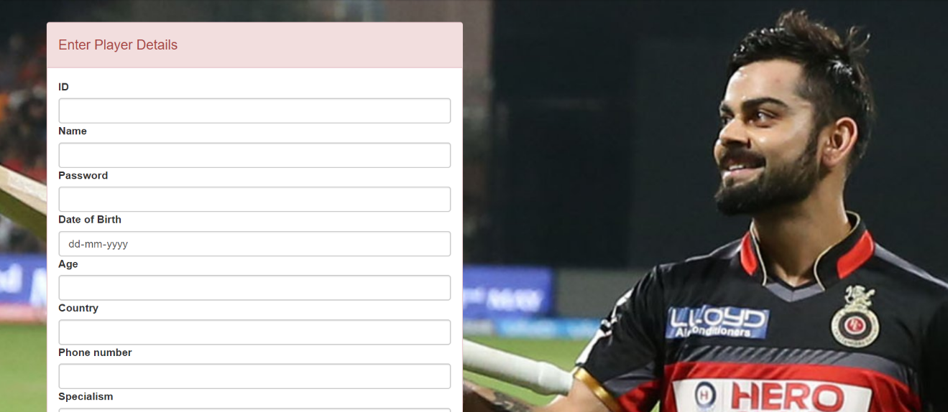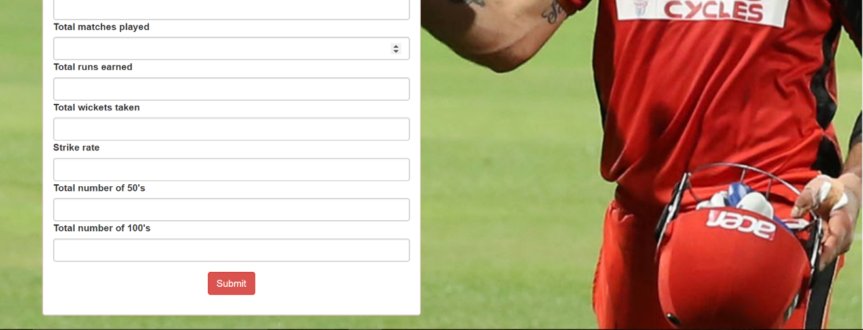

Player added

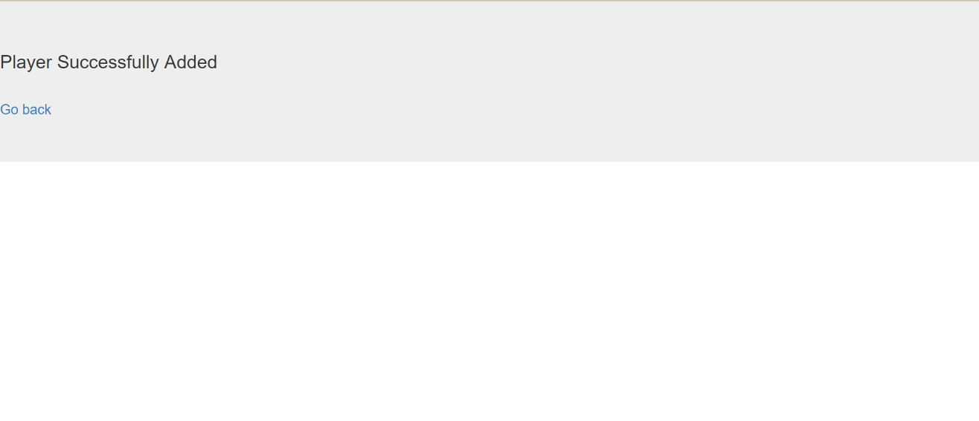

Delete player

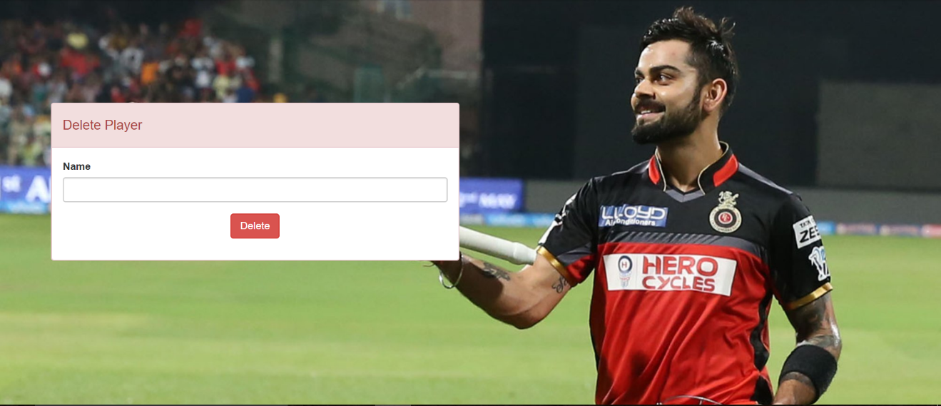

Player deleted

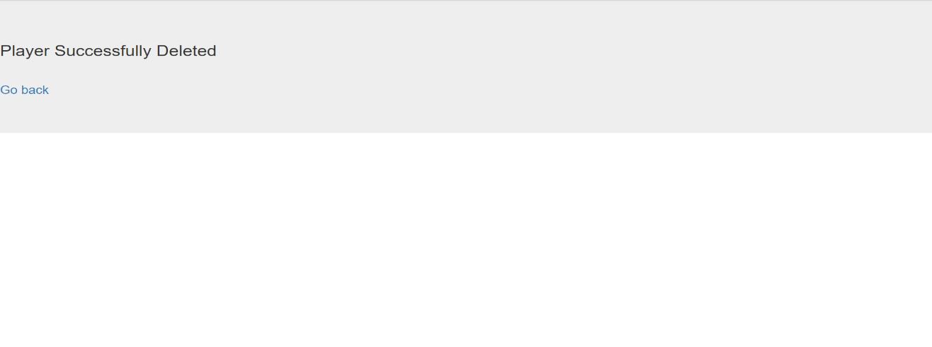

Add manager

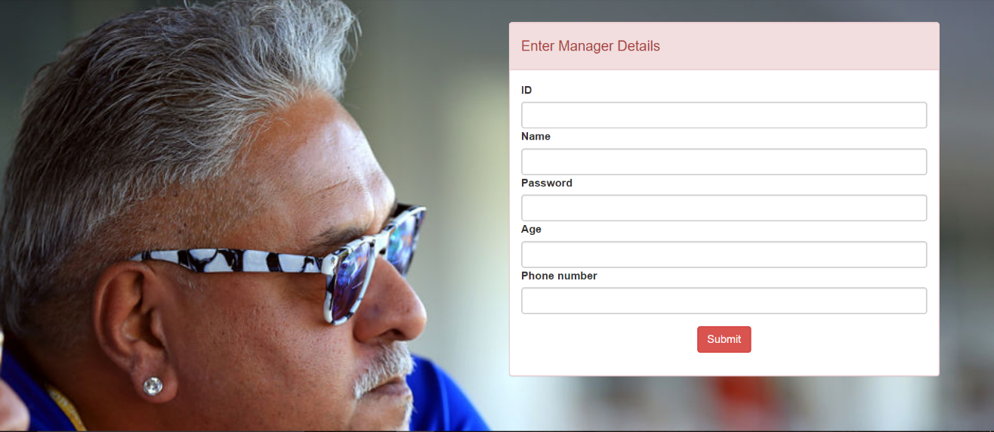

Manager added

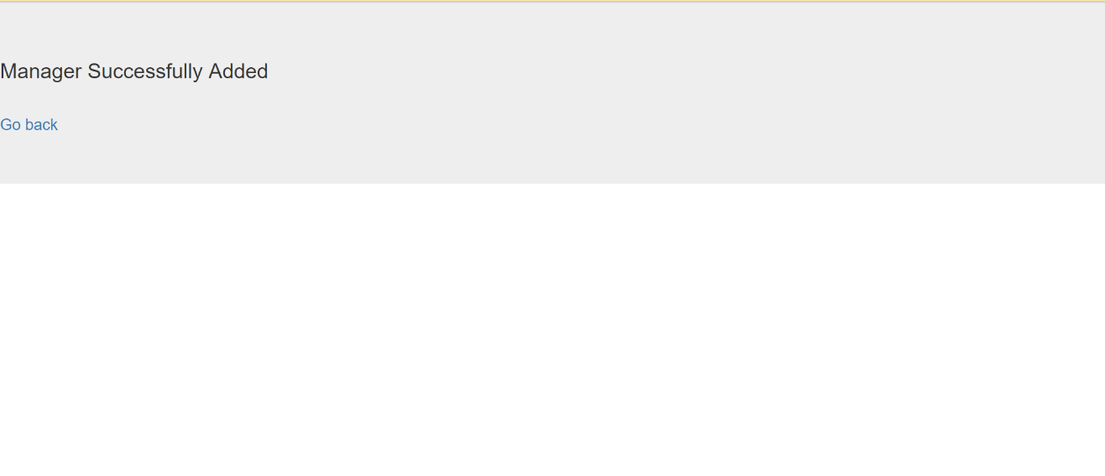

Delete manager

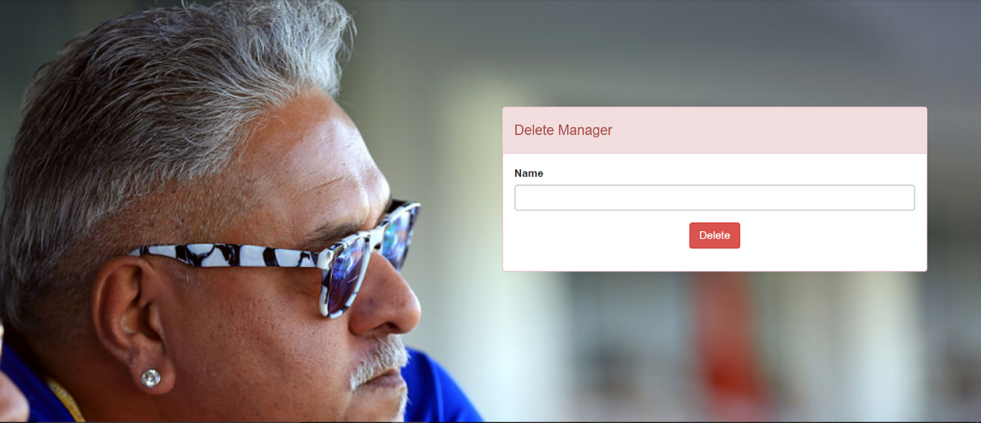

Manager deleted

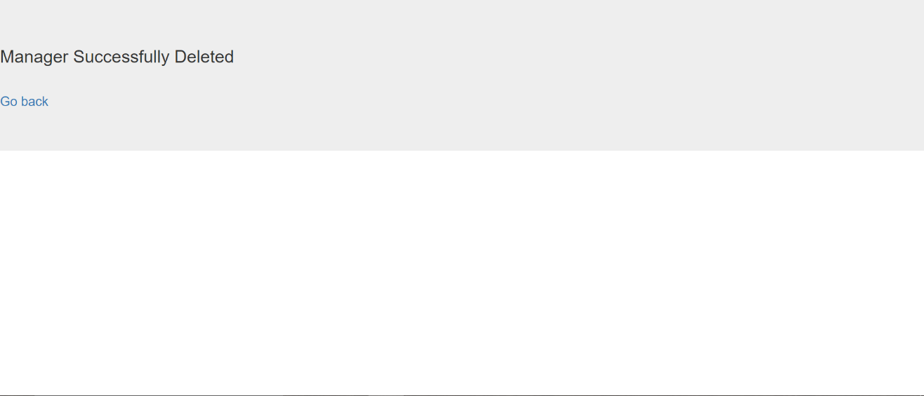

Add team

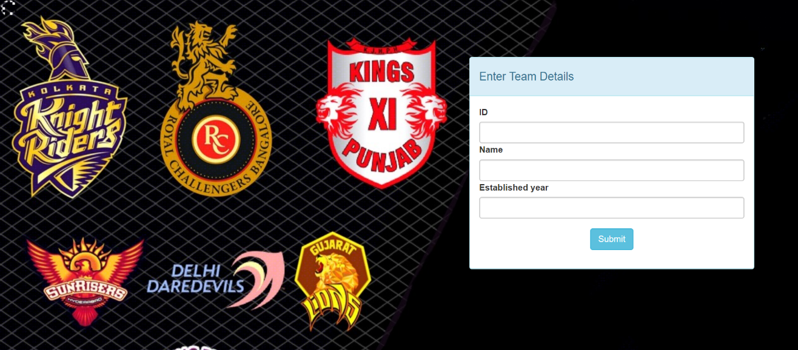

Team added

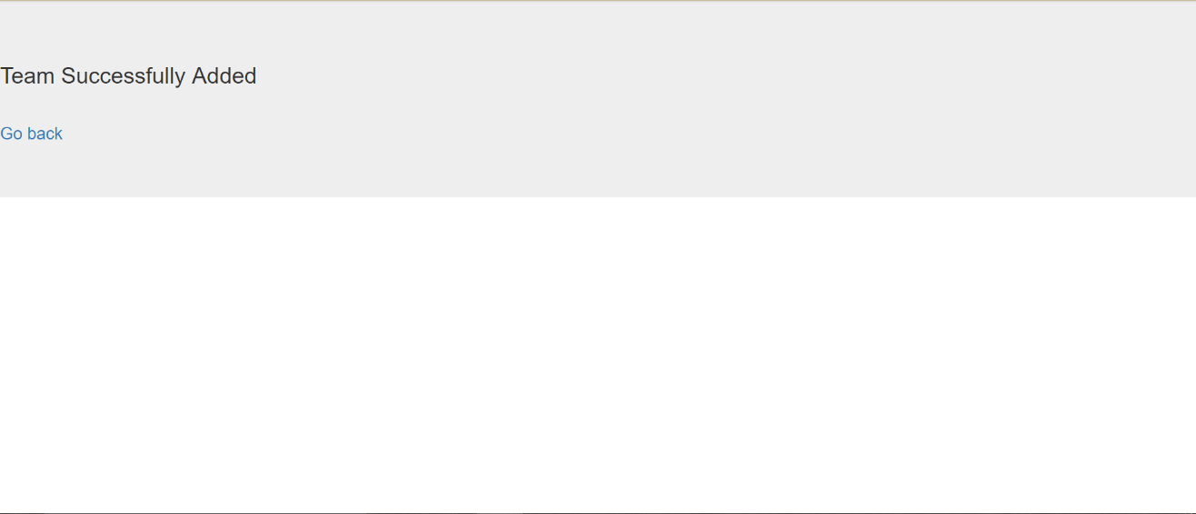

Deleted_team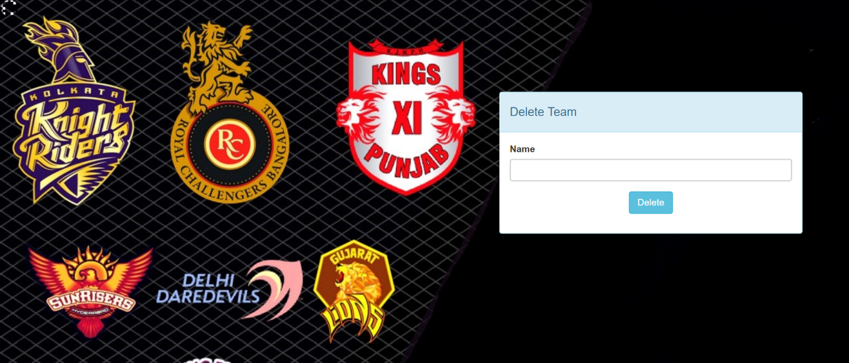

Team deleted

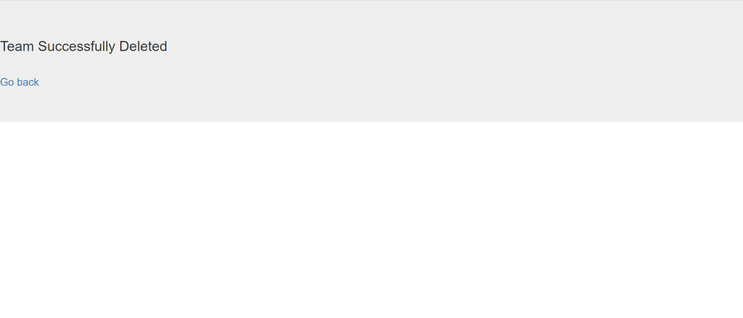

Player login

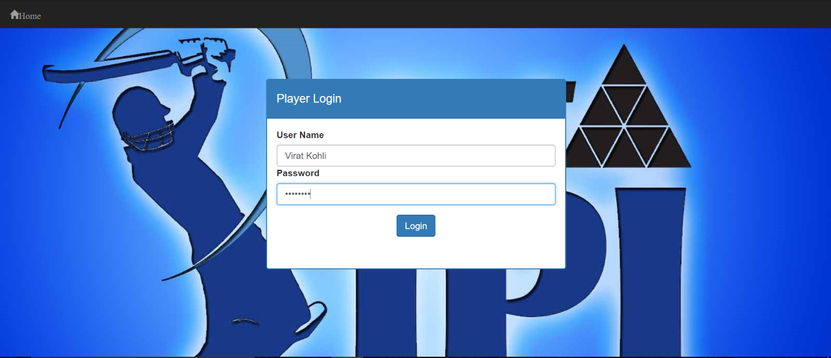

Player details

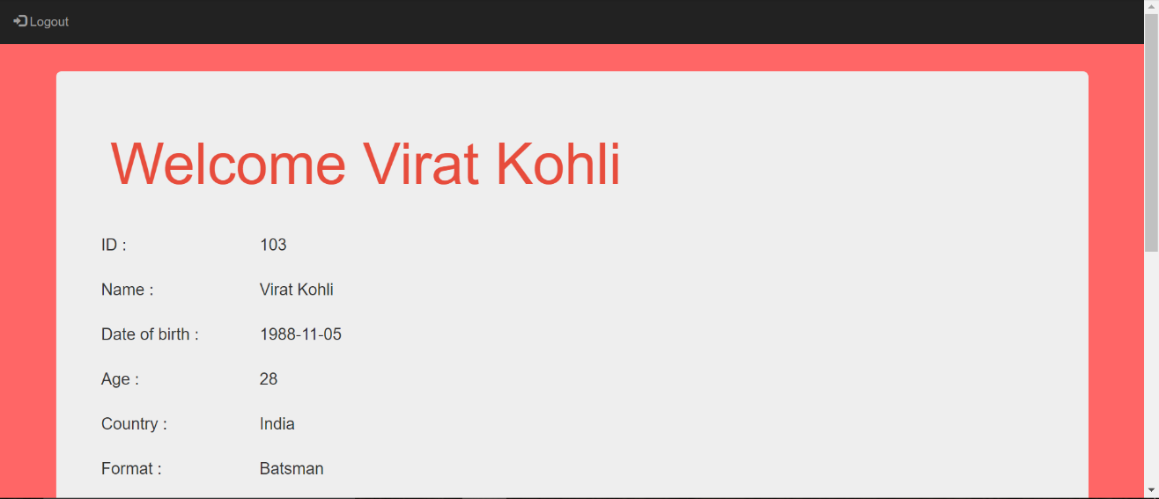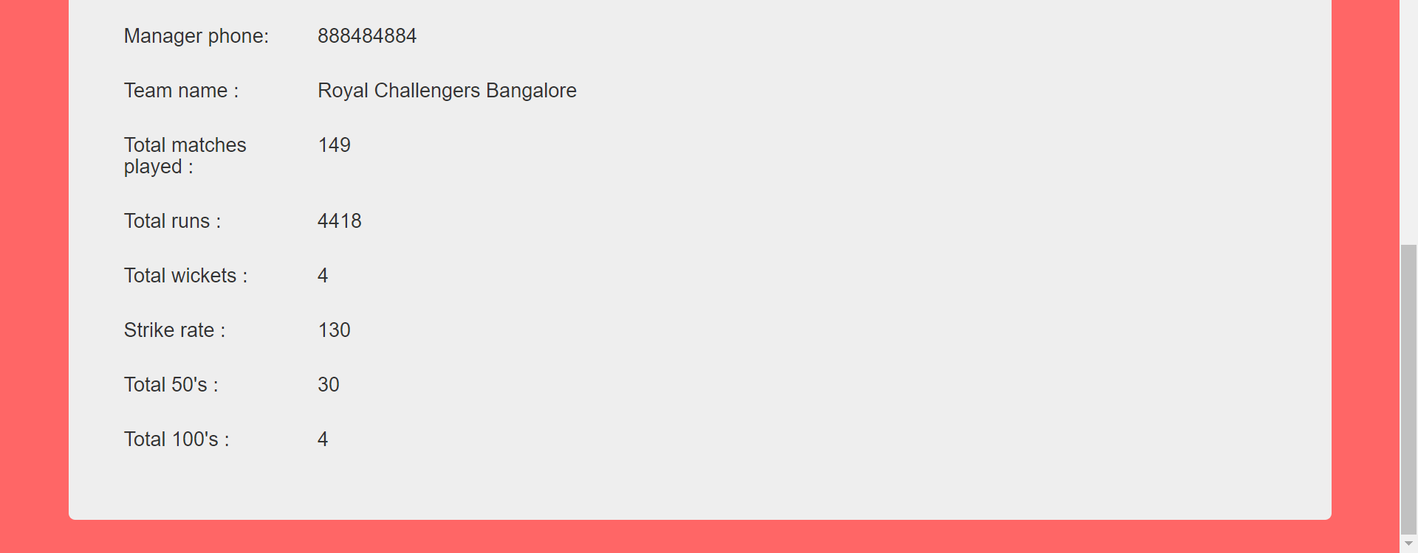

Choose team

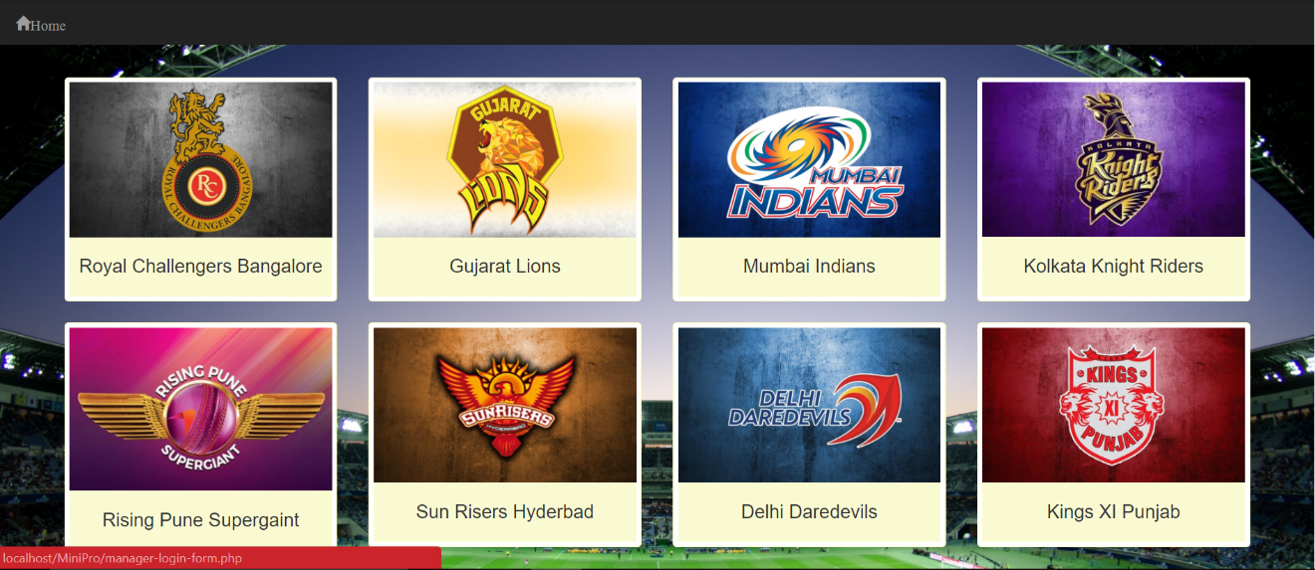

Manager login

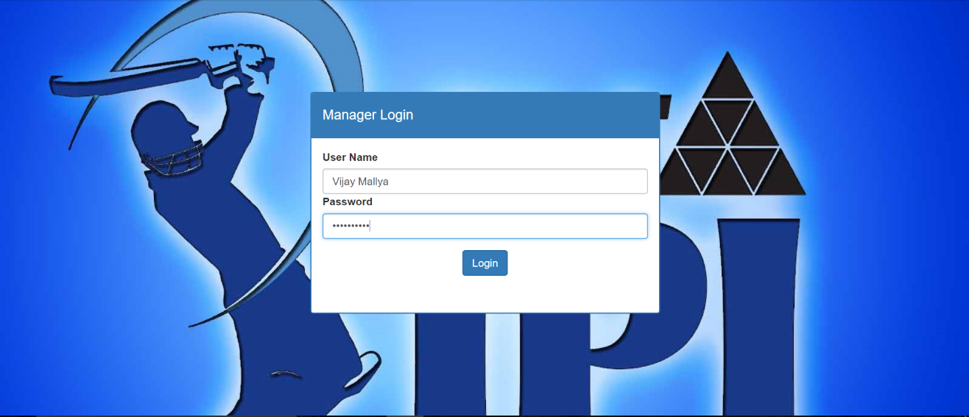

Manager details

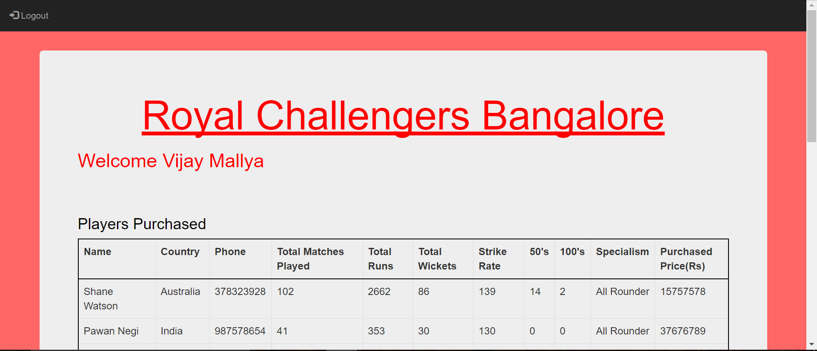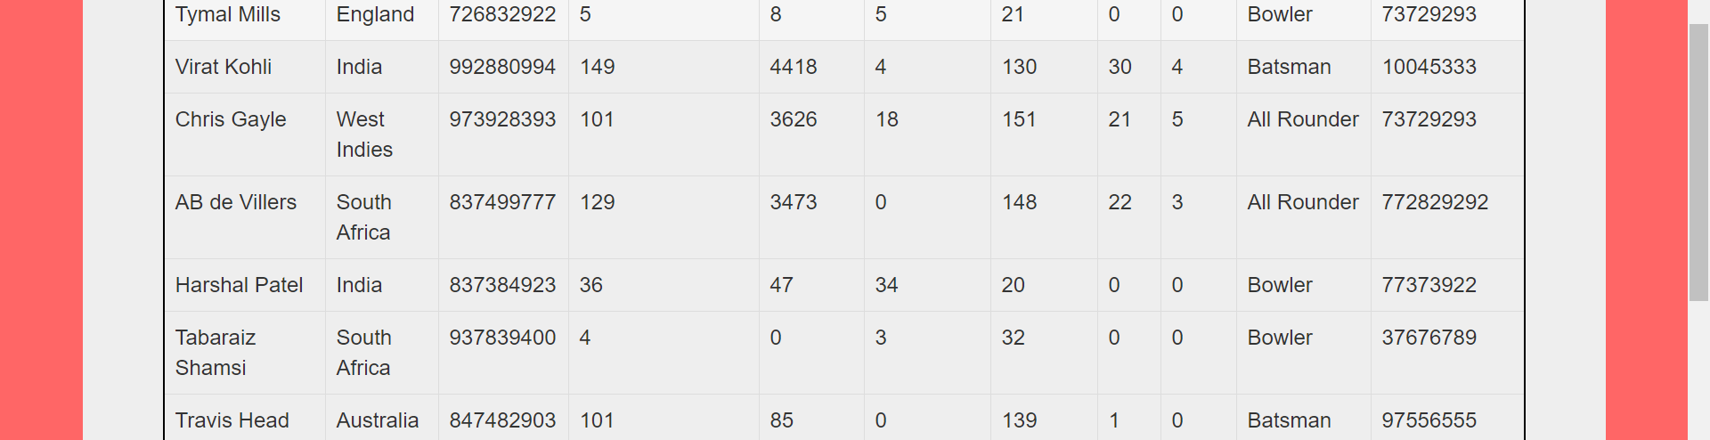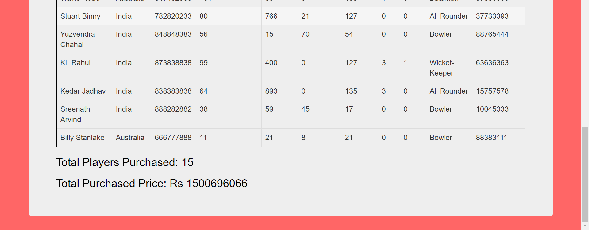

**Table Display**

**a) Manager**

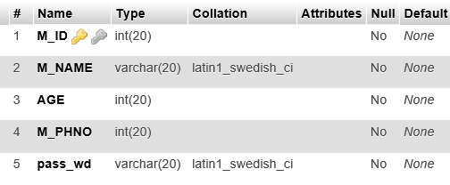

**b) Player**

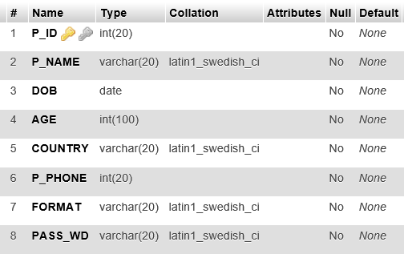

**c)Player_Manager**

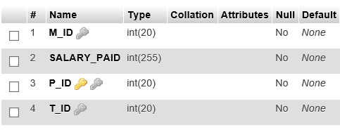

**d) Player_info**

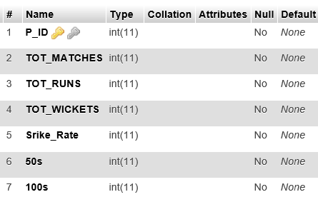

**f)Team**

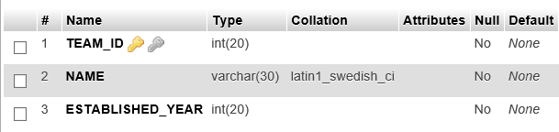

**CHAPTER 6**

**CONCLUSION AND FUTURE ENHANCEMENT**

We planned to do the game with top view available to the viewer. As it was less appealing, we decided to do the front view by drawing and displaying the goalkeeper in the best way possible using the primitive functions in OpenGL.

Basic pictures were obtained, and we implemented it using OpenGL codes to draw polygons, points and lines. After finishing the entire static model, the project proceeded to its next level and that was “animation” for goalkeeper and ball movement.

Animation required delay timer APIs to make each event timed in a proper sequence.

Goalkeeper movement was randomized using the rand() function and it was made to be synchronized with the ball movement.

After a tedious job of repeated testing and modifying the project was ready in well within time.

This game is a 2 player game and it can be used for entertainment purpose. It involves lots of movements and can be used to demonstrate the animations in OpenGl.

**BIBLIOGRAPHY**

1. Fundamentals of Database Systems, Ramez Elmasri and Shamkant B. Navathe, 7th Edition, 2017, Pearson.
2. Database management systems, Ramakrishna, and Gehrke, 3rd Edition, 2014, McGraw Hill.
3. Siberschatz Korth and Sudharshan, Databse System Concept, 6th Edition, McGraw Hill.
4. www.w3schools.com
5. [www.wikipedia.org](http://www.wikipedia.org)
6. www.stackoverflow.com